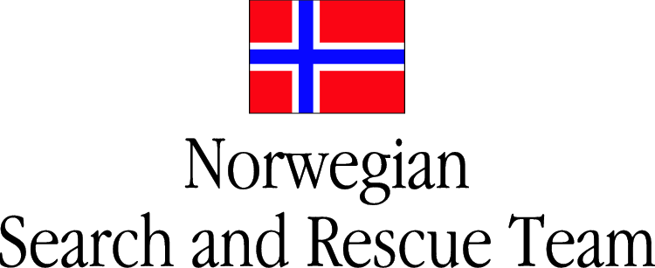
NORSAR
Situation report no 3 12.09.06

Summary
NORSAR arrived in Gotialand at 2040 hrs local time, and made contact with Reception Departure Centre (RDC) in Skoevde at 2200 hrs. RDC was temporarily operated by RAPID UK in anticipation of the arriving UNDAC team. An OSOCC was not yet established.

The information was scarce, with regards to the overall situation and non-USAR relief resources in the area. There were several other USAR teams working in the area, but they were directly coordinated through local LEMA. Neither was there any information regarding current UN Security-phase, but initial assessment suggested not more than precautionary actions taken.

An area for establishment of BoO was assigned through the local Civil Defence in Skoevde. UTM 33V 0435192 – 6473829. Swedish Rescue Services Agency (SRSA) USAR team have also established themselves at this location.

A victim hand-over procedure was established with RDC were possible survivors will be treated on site, transported to the BoO, before handover to other resources mobilised by RDC.

Assignments
An assignment for an assessment on a worksite at UTM 33V 0435632 - 6473997 was given by the RDC.

This location was a partially collapsed, 5 storey building with reinforced concrete. Information from local civil protection suggested that there were 20 possible missing persons at this site, both children and adults.

The whole site was searched with canine and technical device, and some indications were followed up with excavation of all possible voids.

Work site completed without finds.

Other
NORSAR still requests support with 100 litres of diesel, 200 litres of gasoline and drinking-water for a 5 day period.

Contact-information
NORSAR Operations-Centre: GSM: +47 95829545
Iridium: +881621437598
Email: norsar@norske-redningshunder.no

Ove Syslak, Team Leader: GSM: +47 95207608
Rolf M. Bakken Dep. Team Leader: GSM: +47 47233064

