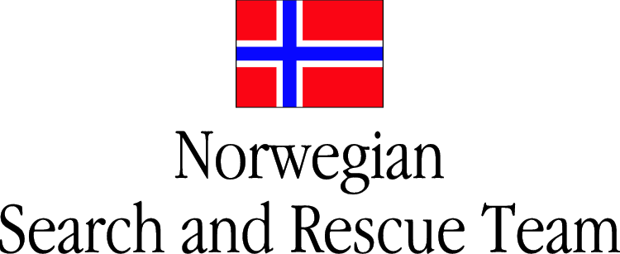
NORSAR
Situation report no 5
13.09.06

Summary
Several USAR-assignments were today given from LEMA to sub-OSOCC for a coordinated response by NORSAR and SRSA. These were divided between the teams based on available resources (see Operations below).

LEMA reminds all USAR teams to use the marking system found in the INSARAG Guidelines. Yesterday, a French USAR-team had searched an unmarked site that had been previously cleared by a USAR-team.

Assessments of other humanitarian needs show infrastructural damages to roads, railways and local public services buildings. However, roads have been partly cleared so there are no obvious signs of logistical constraints. The local population seems to have good coping-mechanisms and have been constructing makeshift-shelters of the rubble. These shelters are adequate with current weather-conditions, but due to low night temperatures and approaching cold season; winterized shelter will be needed soon. Food and water seems to be in abundance. Due to infrastructural damages of sanitary systems, water purification units might be needed soon. There are signs of defecation close to natural water sources that also are utilised as drinking water. Local medical resources are still overwhelmed, but have supported some of today’s operations and seem to be recuperating.

Security is still reported as precautionary, but there have been no reports of incidents since last report.

LEMA are considering when to end the USAR phase as it is now 96 hrs since the earthquake struck and USAR teams have reported finding deceased victims in voids were survival could have been possible.

Operations
During the night, LEMA through sub-OSOCC requested USAR-support at HASLUM, UTM 33V 0435632 – 6473997. One building had collapsed during the earthquake, but local civil defence present at the site had no information about number of missing persons or previous USAR-operations. The site was searched without results.

Also during night-time, USAR-support was requested at SMEDSTORP UTM 33V 0434685-6471762. Several buildings had collapsed, in a small community with a population of 2–300 persons. A local USAR-NGO had been working in there since the earthquake struck, but had exhausted their resources. One person was found alive in the rubble and rescued after several hours of excavation. The person was in good shape without visible injuries.

NORSAR supported SRSA with two rope-rescue specialists and equipment during an operation at KJEPLUNDA, UTM 33V 0431601 – 6474078. Eight persons were missing in a collapsed mine, but access was possible through a ventilation shaft. One person was found and rescued out through the shaft.

NORSAR was requested to support local civil defence with heavy USAR at SMEDSTORP, UTM 33V 0434685-6471762. This is a small village that had been totally destroyed during the earthquake. Local civil defence had worked there since 10.09.06 and was now totally exhausted. NORSAR found two persons, one near the surface and easily excavated and another that was deeply buried under the rubble. The last was excavated by a joint effort of NORSAR and SRSA in a very difficult USAR-operation were the rubble above the victim was very fragile and prone to collapse during removal. Both persons needed immediate medical care and were treated on-site before transportation to local hospital by NORSAR.

At HASLUM, , an 8 storey, sewing factory with elderly employees had suffered from a total collapse. A total of 50 persons were missing, but local civil defence had rescued some victims found near the surface. They needed assistance with heavy USAR as most of the missing persons had been working on the first floor when the earthquake struck. NORSAR located and rescued 8 persons alive from the factory. They suffered from various injuries and was treated and stabilised on-site by NORSAR before transported to hospital by local civil defence.

LEMA requested a joint team from NORSAR and SRSA to search an area at HASLUM UTM 33V 0435632 – 6473997. A total of 16 persons were found; 7 alive by NORSAR, 5 alive by SRSA, and 4 deceased. The survivors were transported to hospital by local resources.

Other
One person from SRSA was injured while supporting NORSAR at SMEDSTORP. His hand was squeezed resulting in an open wound, but no fractures. He was treated on-site by SRSA-medic.

Contact-information
NORSAR Operations-Centre: GSM: +47 95829545
Iridium: +881621437598
Email: norsar@norske-redningshunder.no

Ove Syslak, Team Leader: GSM: +47 95207608
Rolf M. Bakken Dep. Team Leader: GSM: +47 47233064

